**Contact Information**

Name: Clinton Thai

Student No: 3840992

Student Email: [s3840992@student.rmit.edu.au](mailto:s3840992@student.rmit.edu.au)

**Personal Information**

Once again, my name is Clinton Thai. I have half Vietnamese and Chinese blood flowing through my veins. In 2018, my family and I moved here to the wonderful city of Melbourne, Australia. However, I was actually born and raised in the suburb of Mangere which is located in Auckland, New Zealand. Since my move to Melbourne, I have completed VCE in 2018, 2019, and then started my tertiary schooling by studying a Bachelors of Computer Science in 2020, 2021, and then transferred to Bachelors of IT in 2022. I am able to speak three languages, English!, Vietnamese and Teochew (Chinese Dialect). Outside of studying, there are many things that I enjoy. Most of my spare time is spent either with my girlfriend, or on my PC playing games. Back in the day, I played a lot of CS:GO, and so when Valorant was released, I played a lot of that and continue to do so till this day. I also enjoy going to the gym and shooting some hoops at the local courts!

Finally, let me introduce you to my pet dog named Yoshi, which is an Australian Shepherd breed and he is a bit special!

**Interest in IT**

*What is your interest in IT? When did your interest in IT start?*

*Was there a particular event or person that sparked your interest? Outline your IT experience (if any).*

Personally, my interest in IT is within software development, testing and possibly data analytics! My interest in the IT field actually derives from when I was a young child. My uncle introduced me to PC gaming, where from there I eventually learnt how to build a PC, and then ended up actually doing it myself. My love for gaming and technology was nurtured due to my early exposure to it. Since then, I have been the 'tech' guy in my family and friend groups, whereby if there are any technology related issues, they would come to me for assistance. Fast-forward to VCE, I decided to take Units 1-4 of Software Engineering, where I learnt how to code in Java and followed the software engineering process to create my own basic software (which was very bad), but I learnt a lot!

*Why did you choose to come to RMIT?*

There are multiple reasons why I chose RMIT. First of all, just from open days as well as word of mouth, RMIT seemed to have the best courses for the IT field. RMIT just seemed like the perfect option for me, because I wanted to get into a Bachelors of Computer Science, which I luckily did successfully so. Another big reason as to why I chose RMIT was that the location is very easy to get to for me (one train ride), as well as being in the center of the Melbourne CBD.

*What do you expect to learn during your studies?*

Prior to the commencement of my studies, I expected to learn mainly just the Software Development process, as well as a bunch of coding languages. What surprised me though was that in Computer Science, there are (surprisingly) a lot of science related subjects that go hand-in-hand with computers. Some examples of science-y classes that I completed was Discrete Structures (Maths) and Intro to Data Analytics (Python and Statistics).

**Ideal Job**

https://www.seek.com.au/job/56272037

Milanote is offering the position of a Full Stack Developer. What that means to me is that I will be able to work using the software development methodology (Analysis, Design, Development, Evaluation) to create or work on an existing product for the company. This includes front-end, back-end and deployment using AWS of said application. This position offer intrigued me in the sense that the company is a small startup with great people, meaning that I will be hopefully be able to collaborate very closely and form great bonds with everyone. I also have some minimal experience in React and Javascript, as I was a tester for the group project within the class Software Engineering: Processes and Tools. Finally, the pay is also very attractive at $140k-$170k a year plus super too. This also relates t them stating that the hours are quite flexible, and everyone sometimes goes out for team bondings.

The skills required are Javascript/React for the Front-end development. The back-end skills required are MongoDB, Node/Express, Redis, Sockets and REST/API Design. As for the deployment of the application, they use AWS Architecture as well as for security. There are other important skills as well, such as turning front-end performance using JS Profiling, experience in Functional Programming and Sass. Although all these various skills are listed, they say that the candidate is not required to know all of it as they are open to teaching the skills, which is also what makes the job opportunity attractive too.

Currently, I am not that experienced in Full Stack Development. I only have experience in Java development, as well as a bit of Python and C++. In terms of testing, I kind of know how to do it for the back-end using JUnit as well as in the front-end using Jest. I also have a bit of experience in regards to Javascript and React as I worked as the tester for a group project.

I plan on gaining the skills required as well as experience by working on my own personal projects in my own spare time, as well as trying to find entry-level software development jobs possibly in my final year of study or when I've graduated. It is best for me to learn while doing.

**Personal Profile**

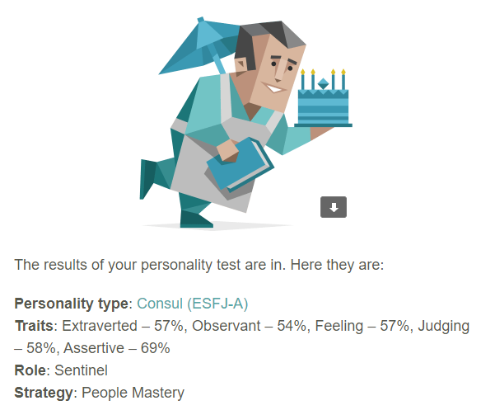

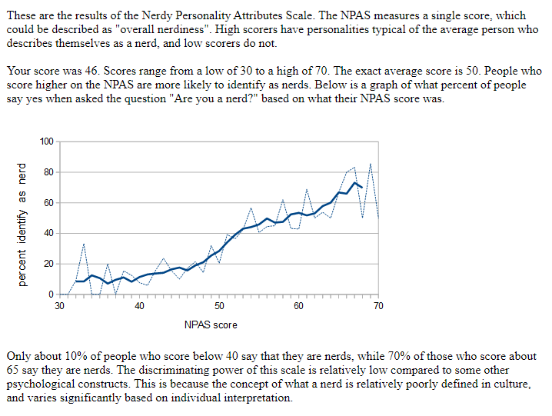

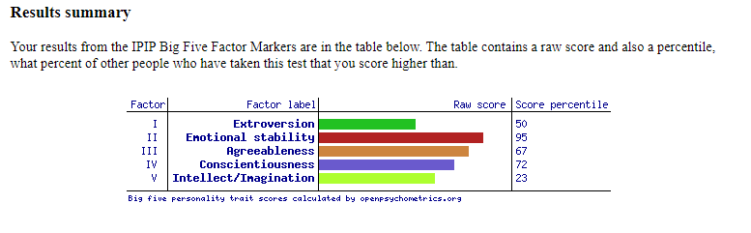

These three test results are all quite accurate and do reflect my personality and behaviour quite well.

The Myers-Briggs test and Big 5 Factors test both conclude that being extroverted is one of my personality traits, which I do agree with as I love meeting people and making new friends, also am pretty good at conversing with others. The Big 5 Factors test say that my strongest trait is that I am very emotionally stable which is true because I am a very patient person that doesn’t get stressed very easily. Also, according to the Nerdy Personality Test, I am apparently in the lower ends of nerds, where I am very much not a nerd, which I think is funny because gaming, anime and manga is a big thing in my life. Because these results show that I am very outgoing, I think that means that I will be able to bond very well with my teammates. I am probably very easy to work with because of my agreeableness and emotional stability, which help in my stress management as well as everyone else. One thing I do not agree on though, is my assertiveness score of 69% in the Myers-Briggs test, because personally I think I am not assertive enough, which makes me out to be someone that is not quite cut out to be a leader. Meaning that when forming a team, I will most likely not take up the leadership role.

**Project Idea**

Overview

Majority, if not everyone has watched a movie or read a book at least once in their lifetimes. This project takes us through the idea of creating a book/movie tracker whereby users are able to keep track of their entertainment media history.

Motivation

Entertainment. It is a big part of everyone's lives whether it be movies, books, music, podcasts and games. However, these days, it is so easy to consume these materials. All that is needed are a device and internet connection. Services such as Netflix, Booktopia and Binge have endless amounts of movies and books, that people generally struggle to run out of entertainment options. As a result of mass media consumption, people tend to forget the shows they have watched, or the books they have read. Quoting Julie Beck from (theatlantic.com),

“The experience of consuming culture is like filling up aa bathtub, soaking in it, and then watching the water run down the drain”.

Description

The proposed solution is a mobile/web application in which as a user watches a movie or reads a book, they can add that towards their ever-growing personal list, as well as keep track of number of episodes watched, give ratings and write personal reviews or synopsis. If they ever need to recall a movie/book, it is all in their database with a blurb and rating to help them recall how good it was.

The process is as follows. The user is either currently or have completed watching/reading their media. They want to submit/update their progress. They open up the application, then press a button for a new entry. They are then prompted to enter the relevant details of the media such as name, director/author, episodes watched, pages read, rating and description/review/synopsis. They could also possibly upload an image as well, such as the cover photo or snapshot of a specific enticing scene. They then submit the entry, and it will reflect on their watch/read list. After that, the user is not only able to view their media history, but also edit the entry for the instances where they watched new episodes or read more pages.

Aside from personal use, users may also be able to share their individual entries, or their complete lists so that other friends/family can view it. This could possibly be achieved through storage of entries into a CSV, in which the application can export and import CSV files.

Tools and Technologies

The tools and technologies required are: computer, IDE and chose coding language or text editor. This project can probably be implemented using either Java or Python however it might be the simplest to implement is as a website using HTML and CSS. The chosen language must be coupled together with any IDE such as IntelliJ or Visual Studio, and Atom or Notepad++ for HTML/CSS. Other than that, an appropriate device with recent specs and running any recent operating systems such as Windows 10/11 or any recent macOS.

Skills Required

The developer/s should be reasonably skilled in whichever coding language they choose. If it is Java or Python, it may be a bit more difficult as they would have to code the application logic as well as creating the user interface. Not only that, but they also must work with CSV file manipulation (import, export, read and write) which all require more skill and competency from the developer/s. Even more advanced, the developer/s may decide to create the frontend using JavaScript, and then code the backend on Java. Some skill is also needed to implement the idea onto a website using HTML/CSS as the user interface may be simpler, but the logic and file manipulation is still required. Although a fair amount of skill is required, it is nothing too farfetched/tech-company ready level. It is quite feasible to find the skills. No special hardware is required, and IDEs/Text editors are free software.

Outcome

Once the project has been successfully implemented, many users are able to reliably have a website/application to refer to, to create a personal media history. Many users online who have forgotten an old movie, and only remember some small part of the movie may be able to search through their list and find it without having to go through the painful experience of trying to google it based on a vague memory. Users who are watching long series or reading long books may also use the website/application as a bookmark, where they can update their progress, and come back to it in the future being able to find out where they last left off. This development is not a large and probably necessary one in retrospect to the many innovative applications that have been created, however it suits more as being a quality of life improvement for many users.

**Bibliography**

Milanote Job: https://www.seek.com.au/job/56272037

Myers-Brigs Type Indicator: <https://www.16personalities.com>

Big 5 Factors: https://openpsychometrics.org/tests/IPIP-BFFM

Nerdy Personality Test: https://openpsychometrics.org/tests/NPAS